NAME: RAFIQUL HASAN SAKIB

ID: 1510797042

PART2

QUESTION 1:

.MODEL SMALL

.STACK 100H

.DATA

NUM1 DB ?

NUM2 DB ?

RESULT DB ?

MSG1 DB 0DH,0AH,"ENTER Integer 1 : $"

MSG2 DB 0DH,0AH,"ENTER Integer 2 : $"

MSG3 DB 0DH,0AH,"Mul of the integers : $"

ENDS

.CODE

ASSUME DS:DATA CS:CODE

START:

MOV AX,@DATA

MOV DS,AX

LEA DX,MSG1

MOV AH,9

INT 21H

MOV AH,1

INT 21H

SUB AL,30H

MOV NUM1,AL

LEA DX,MSG2

MOV AH,9

INT 21H

MOV AH,1

INT 21H

SUB AL,30H

MOV NUM2,AL

MUL NUM1

MOV RESULT,AL

AAM

ADD AH,30H

ADD AL,30H

MOV BX,AX

LEA DX,MSG3

MOV AH,9

INT 21H

MOV AH,2

MOV DL,BH

INT 21H

MOV AH,2

MOV DL,BL

INT 21H

MOV AH,4CH

INT 21H

ENDS

END START

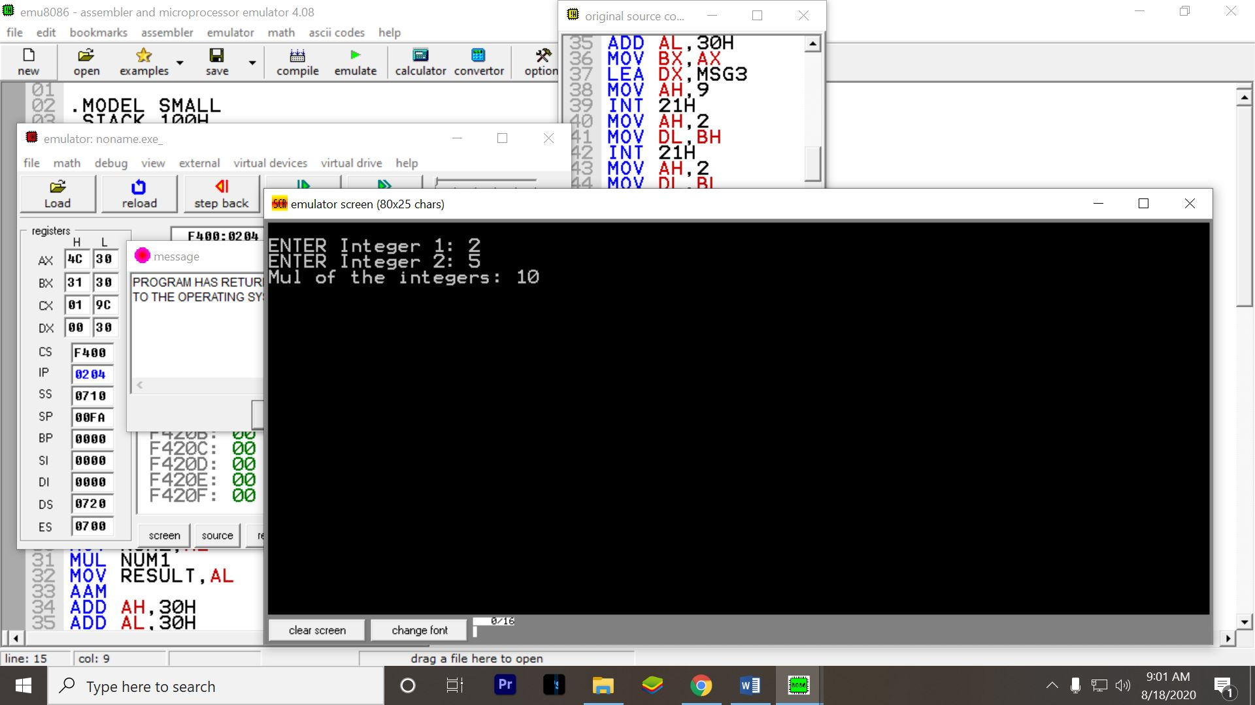

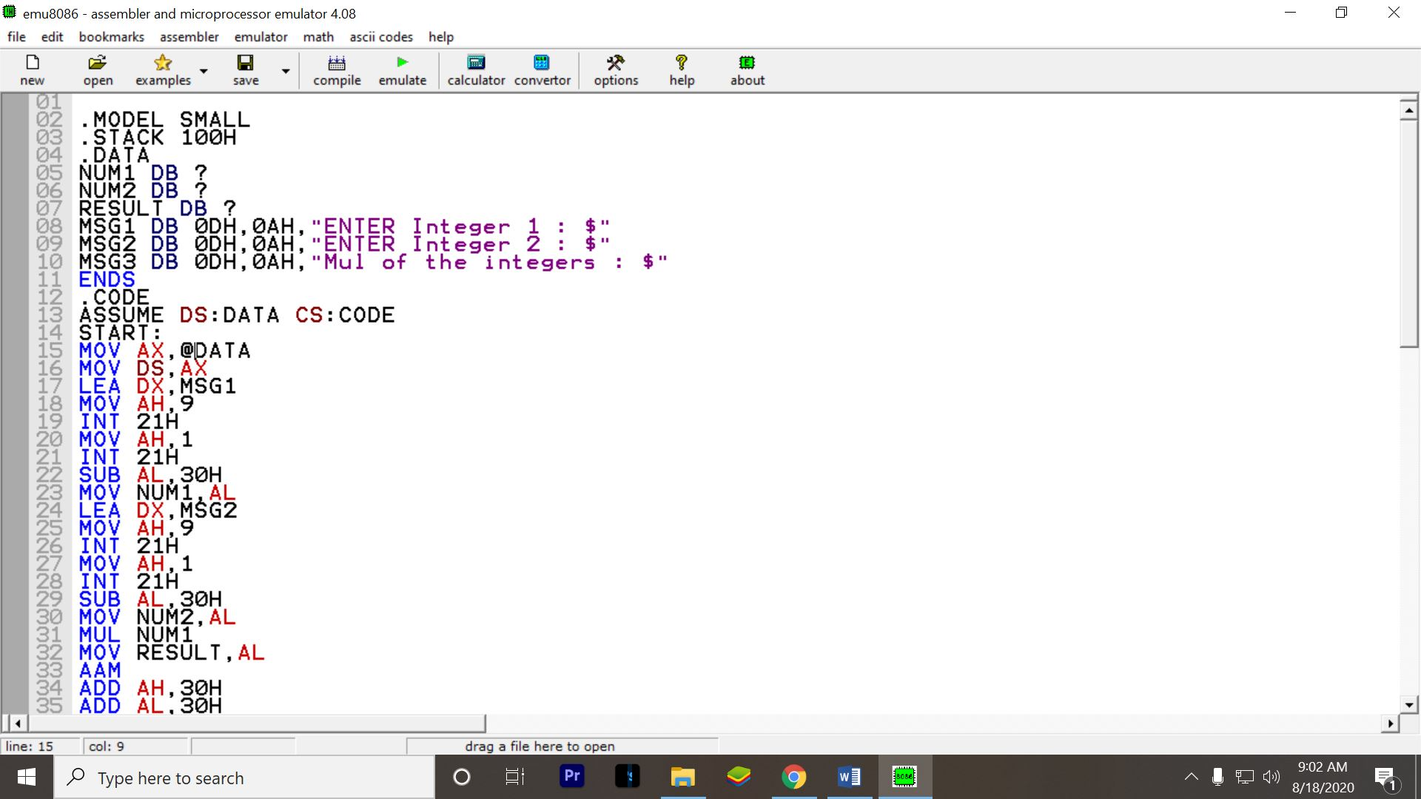

Question 2 :

